Notes: Weathering/Earth Science/Miss Cohn
Name:____________________________________________ Date:___________________

Weathering is defined as:

There are two types of weathering:
- Physical/Mechanical Weathering:

- Chemical Weathering:
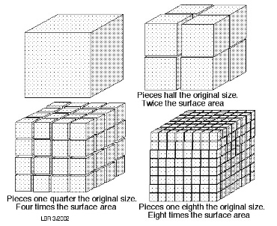

How fast a rock weathers is determined by:
- The ________________________ of material ___________________ at the surface .
  - As the surface area ____________________, the rate of weathering _____________________. (This means that smaller particle sizes, of the same composition, will weather faster).

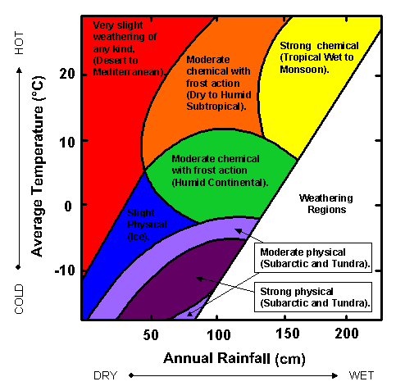
- __________________- This refers to the average moisture and/or heat available in a geographic location

Looking at the diagram to the right:
  - Strong chemical weathering dominates in areas with ________________ annual rainfall and ____________ average temperature.
  - Strong and moderate physical weathering dominates in areas with moderate to high annual rainfall and average annual temperatures that reach below ________ C.
  - Slight weathering of any kind, takes place in areas with ___________ average temperatures and very low annual rainfall.

- _________________ _____________________:
  - Chemical:
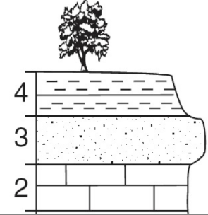
  - Physical:
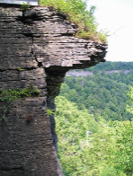
Key Concept: The more resistant rock will be weathered __________________ than the __________ ones. Which layer in the diagram to the right is the most resistant to weathering?
Types of Weathering | Name and Physical/Chemical? | Description
